Anaesthetic considerations for liver resections in paediatric patients

Mogane P, MBChB, DA, FCA, Senior Specialist, Chris Hani Baragwanath Academic Hosptial, Johannesburg
Department of Anaesthesia, University of Witwatersrand, Johannesburg
Motshabi-Chakane P, MBChb, DA, FCA, Principal Specialist, Charlotte Maxeke Johannesburg Academic Hospital, Johanensburg
Department of Anaesthesia, University of Witwatersrand, Johannesburg
Correspondence to: Palesa Mogane, e-mail: moganep@gmail.com
Keywords: anaesthetic management, liver resection, paediatric patients

Abstract

Children presenting for liver resection form a challenging population with co-morbidities requiring adequate preoperative assessment and planning to improve postoperative outcomes. With the development of new surgical equipment and techniques, the anaesthestist is in a precarious position in which a delicate balance is needed between delivering organ-protective anaesthesia and providing haemodynamic stability that will allow for optimal surgical results. This review will highlight some of these aspects.

Introduction

Hepatic tumours represent one per cent of all paediatric malignancies and five per cent of all extracranial solid tumours. The liver is the third most common site of intra-abdominal malignancies, following adrenal neuroblastoma and Wilms’ tumours.¹ Significant perioperative morbidity and mortality have been quoted to be high as 19% in one publication.² However, recent advances in anaesthesia and surgical management have significantly reduced the operative risk. This review will attempt to focus on aspects of management that are important to the anaesthestist.

Presentation

Seventy to eighty per cent of all primary liver tumours in children are malignant. Hepatoblastoma and hepatocellular carcinoma are the most common (Table I). Benign tumours are rare and the majority consists of hemangiomas or hemangioendotheliomas.^{2,3}

Table I: Lesions of the liver in children⁴⁻⁶

Malignant
Liver cell carcinoma:
- Hepatoblastoma
- Hepatocellular carcinoma
Hepatic mixed tumours
Mesenchymoma (malignant)
Sarcoma
Metastatic tumours
Benign
Tumour-like epithelial lesions
Focal nodular hyperplasia
Multiple nodular hyperplasia
Accessory lobe
Benign epithelial tumours
Adenoma
Adrenal rest tumour
Cysts and tumour-like mesenchymal tumours
Mesenchymal harmatoma
Nonparasitic cyst, e.g. hydatid, choledochal cyst
Benign mesenchymal tumours
Cavernous hemangioma
Infantile hemangioendotheliomas
Teratomas

Children with hepatic tumours present with abdominal distention, a palpable abdominal mass, or both. Anaemia, thrombocytopaenia and leukocytosis are sometimes present. Children with hepatoblastoma and hepatocellular carcinoma may also present with weight loss, fever and anorexia. As the tumour grows, pain may progress to the shoulder.

Tumour growth may compress or obstruct the normal hepatic architecture, causing:

- Ascites secondary to occlusion of the portal or hepatic veins.
- Gastrointestinal bleeding or splenomegaly from portal hypertension, portal vein occlusion or jaundice.
- Scleral icterus and pruritus from obstruction of the biliary tree.⁷

Preoperative workup

Biochemical tests include full a blood count, urea and electrolytes, liver enzyme levels, liver synthetic function and alpha-fetoprotein (AFP) levels. AFP is the most important tumour marker, whose levels are elevated in 50-70% of children with hepatic neoplasms.⁷ Multiple studies confirm that AFP is a valuable surveillance marker in children who have previously undergone liver resection for malignancy, those with unfavourable tumour biology, poor response to chemotherapy and poor outcomes.^{1,7} Since complete surgical resection offers the only possibility of permanent cure, imaging studies are of utmost importance. Ultrasound and Doppler imaging can be used to localise the tumour and evaluate the patency of the IVC, hepatic veins and portal vein. Magnetic resonance imaging, computed tomography scan and an angiography of the abdomen and chest are generally used for indeterminate or solid lesions to further delineate the location, extent and multiplicity of the lesions, and to detect vascular involvement and metastases (Figure 1).^{1,7}

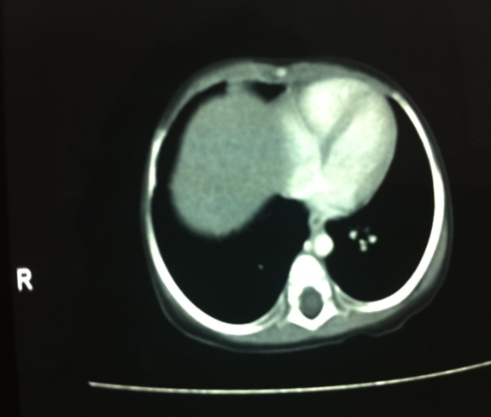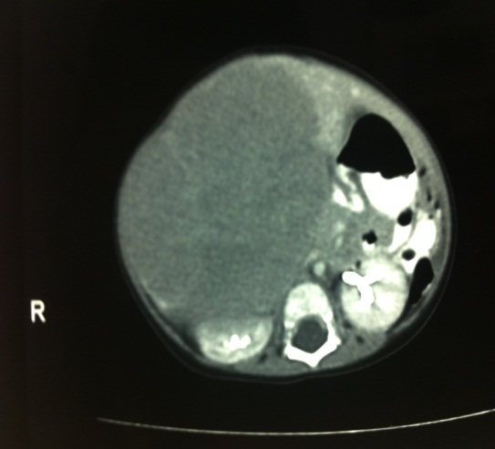

Figure 1: Computed tomography scan showing right lobe hepatoblastoma compressing the inferior vena cava

Surgical technique

The surgical aim is to excise the diseased part of the liver with adequate oncological clearance, minimal blood loss, and preservation of enough healthy liver to avoid liver failure and allow regeneration. The surgical procedure can be divided into two distinct phases, pre- and post-resection.⁶ Safe resection can be obtained through a generous transverse abdominal incision. It is rarely necessary to enter the thoracic cavity in children, even for resection of the largest hepatic tumours.⁵ The first step in resection is mobilisation of the liver by dividing its ligamentous attachments to the abdominal wall and diaphragm. The liver can be displaced almost out of the abdominal cavity in smaller children, to provide access to the retrohepatic vena cava. This may be associated with a sudden fall in cardiac output and central venous pressure, which necessitates repositioning the liver into its normal anatomical position until stability returns. The next step is isolation of the portal vein, common bile duct, and hepatic artery from the lobes and segments that are being resected.⁵ Extreme care to protect the vascular and biliary structures to the remaining portion of the liver has to be exercised. Ligation of the hepatic veins is the most difficult and hazardous part of the surgery. Avulsion or injury of the hepatic veins can result in massive haemorrhage.

Several vascular occlusive techniques have been used in an attempt to minimise blood loss at this stage. Options include inflow vascular occlusion and a combination of inflow and outflow vascular exclusion manoeuvres (Table II).

Table II: Vascular occlusive techniques⁸

Inflow vascular occlusion

- Hepatic pedicle occlusion: Continuous Pringle manoeuvre and intermittent Pringle manoeuvre
- Selective inflow occlusion
Inflow and outflow vascular exclusion

- Total hepatic vascular exclusion
- Inflow occlusion with extraparenchymal control of the major hepatic veins, with selective hepatic hepatic vascular exclusion or hepatic vascular exclusion with preservation of caval flow

Haemodynamic consequences

Both the common hepatic artery and portal vein are controlled in the hepatoduodenal ligament (Figure 2) using the Pringle manoeuvre. The liver can tolerate up to 60 minutes of continuous occlusion and 120 minutes of intermittent occlusion.⁶

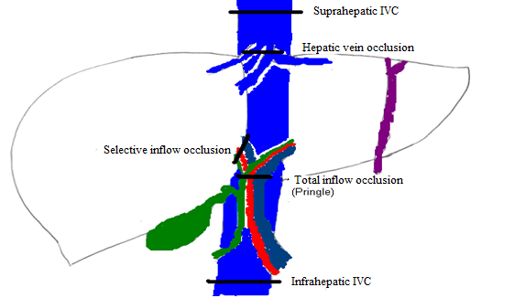

IVC: inferior vena cava

Figure 2: Diagrammatic representation of vascular occlusive techniques

Selective inflow occlusion with hepatic artery and venous inflow isolation has far greater popularity as it allows normal inflow to the remaining liver segment, while preventing ischaemia and reducing bleeding during the parenchymal transection.

Inflow vascular occlusion has been associated with an increase in systemic vascular resistance of up to 40%, a 10% reduction in cardiac output and a mean arterial pressure increase of approximately 15% in the adult population.⁸ Following unclamping, haemodynamic parameters gradually return to baseline values.

Total vascular exclusion combines portal vessel clamping with occlusion of the supra and infrahepatic IVC, with significant haemodynamic consequences. The rapid haemodynamic changes are due to surgical events, such as caval clamping, sudden blood loss and hepatic reperfusion. Cross-clamping of the IVC and portal vein results in a 40-60% reduction in venous return and cardiac output, with a compensatory 80% increase in systemic vascular resistance and a 50% increase in heart rate.^{6,8} Although systemic vascular resistance and heart rate increase, the cardiac index is reduced by half secondary to the preload reduction.⁸ Unclamping is followed by an increase in cardiac index and a significant reduction in systemic vascular resistance.^{6,8}

New surgical devices have been developed to facilitate bloodless transaction, without the need for vascular occlusion. This includes ultrasonic cutting and coagulation devices, pressurised jets of water, the LigaSure™ Vessel Sealing System dissecting sealer and endoscopic staplers.⁹ With these new techniques, up to 75% of the liver parenchyma can be resected with maintenance of normal liver function postoperatively.

Anaesthetic considerations

Preoperative assessment

Preoperative assessment should be adapted to the needs of each individual patient, based on general co-morbidities and hepatic function. This should include routine blood workup and radiological imaging. Pre-existing hepatic impairment is a risk factor, with even higher blood transfusion requirements, longer hospital stay and increased mortality. It must also be remembered that a number of patients presenting for resection will have received neoadjuvant chemotherapy, commonly cisplatin, doxorubicin, vincristine or 5-fluororacil.^{4,5} These have multiple systemic effects which may reduce functional reserve. A thorough cardiorespiratory assessment is necessary in these cases.

Conduct of anaesthesia

Liver resection is conducted under general anaesthesia with tracheal intubation and mechanical ventilation.⁹ Patients with ascites should undergo rapid sequence induction. Cisatracurium and atracurium are the nondepolarising agents of choice in these patients because of their non-liver-dependent metabolism. The most commonly used volatile agents in an oxygen/air mixture include desflurane, sevoflurane and isoflurane. Isoflurane has a mild cardiodepressive effect, but maintains hepatic oxygen supply because of vasodilatation in the hepatic artery and portal vein. They all upregulate heme oxygenase-1, release iron and carbon monoxide, and thus decrease portal vein blood flow, but increase hepatic artery blood flow. Some studies imply that ischaemic preconditioning with sevoflurane before inflow occlusion limits postoperative liver injury.⁸ An advantage of the usage of desflurane is that it undergoes only minor biodegradation, and may cause less hepatocellular damage because of its reduced metabolism. Nitrous oxide should be avoided as it causes gut distention and there is a small risk of air embolism. Antibiotic prophylaxis is given routinely, although local policy may suggest the most suitable choice.

Monitoring

Invasive arterial and central venous pressure monitoring allows for haemodynamic control and regular blood sampling as rapid catastrophic bleeding is possible. Large-bore intravenous access must be established and a rapid infusion system should be immediately available. Central venous pressure (CVP) monitoring may not be reliable during liver resections because of the pressure exerted by surgical retractors on the diaphragm, increasing intrathoracic pressure, and consequently CVP.¹⁰ Clamping of the liver vessels reduces the venous return to the heart and therefore decreases CVP.¹⁰ In addition, changes in patient position and intrathoracic pressure by positive end expiratory pressure and intermittent positive pressure ventilation have thrown more doubt on the usefulness of this monitor during hepatic surgery.¹¹ Transoesophageal echocardiography, pulmonary artery catheterisation and arterial waveform-based techniques have all been suggested for cardiac monitoring. Hypoglycaemia is a real concern, especially during hepatic vascular occlusion and after specimen resection, so blood glucose should be closely monitored. Nasogastric and nasojejunal tubes are inserted to enable postoperative stomach drainage and enteral feeding. Intraoperative coagulopathy should be monitored and appropriately corrected.¹⁰

Haemodynamic management

Inflow vascular occlusion

Continuous Pringle manoeuvre, intermittent Pringle manoeuvre and selective inflow occlusion share common haemodynamic management. Anaesthetic management is dictated by the surgical approach and the patient’s health status. A low CVP of between 2 and 5 mmHg, while aiming for euvolaemia, forms the cornerstone of strategies to minimise bleeding.^{6,8-10} This is often a point of heated debate because of the fallacy of the CVP as a monitor during this type of surgery.¹⁰ This can be achieved with the limitations of intravenous fluids, ensuring diuresis, and if ineffective, the usage of vasoactive agents like nitroglycerine.⁸⁻¹⁰ The advantages of a low CVP must be weighed against inadequate perfusion of the vital organs and loss of volaemic reserve in the case of bleeding and/or air embolism.

Inflow and outflow vascular occlusion

Total hepatic vascular exclusion (THVE) leads to preload reduction and a sudden decrease in cardiac output evoked by the IVC and portal vein clamping. Prior to this taking place, the anaesthestist must take prompt steps to correct the volume deficit, improve splanchnic circulation, displace fluid into the bowel compartment and reduce bowel oedema.⁸ Blood pressure and circulatory support is achieved by aiming for a CVP of at least 14 mmHg.⁸ Vasoactive agents are administered if volume loading is inadequate to maintain blood pressure following clamping of the IVC. There is no standard approach to the use of vasoactive agents. They have to be used carefully, as they may improve cardiac output at the expense of microcirculatory blood flow. Perioperative fluid shifts, intravascular hypovolaemia and sympathetic activation during THVE result in the reduction of renal blood flow. Mannitol, furosemide and “low-dose dopamine” have been used with the aim of preventing intraoperative renal injury, without evidence of substantial benefit.⁸ It is essential to perform a manual test clamp prior to formally applying clamps as 10-15% of patients become significantly haemodynamically unstable, requiring venovenous bypass. Haemodynamic intolerance to THVE or ischaemia under THVE exceeding 30-60 minutes may also require venovenous bypass. THVE should be limited to selected cases as haemodynamic intolerance has implications on morbidity and extended hospital stay.

Selective hepatic vascular exclusion (SHVE) is favoured by many institutions as the standard method of vascular control because it provides a bloodless surgical field and is generally well tolerated by patients.^{6,8} Special anaesthetic considerations with regard to haemodynamic management of SHVE are similar to those for inflow vascular occlusion techniques, as this method diminishes blood pressure and heart rate fluctuations during liver resection. SHVE is the method of choice in cases when CVP cannot be lowered, and a very high or refractory CVP persists, such as in right heart failure, poor cardiovascular status, or when the tumour encroaches on the IVC.

Blood-sparing techniques

Intraoperative blood salvage should be used during major liver resection. However, with the advent of new surgical equipment and vaso-occlusive techniques, blood loss is kept at a minimum. The use of aprotinin has shown significant reductions in blood transfusion requirements in liver transplants and resections. Caution has been advised against routine use of this agent¹² because of serious safety concerns pertaining to the raised incidence of life-threatening allergic reactions, thrombotic potential and renal failure. Tranexamic acid usage has been shown to reduce blood requirements in liver transplant and resection surgery, although safety concerns have not been proved.^{8,12} Blood products must be replaced accordingly in the event of significant haemorrhage.

Analgesia

Regional anaesthesia

The use of caudal or epidural analgesia has been shown to be highly effective in controlling postoperative pain, following elective liver resection. Boluses or continuous infusions of opiods with or without local anaesthesia protocols have been proposed.¹⁰ It may be argued that there could be an incidence of catastrophic complications in this population if there was pre-existing coagulopathy or massive blood loss.^{9,10} Thus, the decision to use regional anaesthesia must be individualised according to preoperative state and predicted intraoperative course.

Intravenous analgesia

A combination of paracetamol, opiates, ketamine and nonsteroidal anti-inflammatories (NSAIDs) may be considered. Paracetamol significantly reduces the requirements for morphine postoperatively, despite its propensity to cause liver failure because of its hepatotoxic metabolite. It is safe in all but the most extensive liver resections. NSAIDs are likely to worsen pre-existing renal dysfunction frequently associated with liver resections, and should therefore be used with caution.¹⁰

Vascular air embolism

Factors predisposing to vascular air embolism during liver resection include surgical technique, size and site of the tumour, blood loss and low CVP techniques. Resections of large tumours in the right lobe, close to the IVC or the cavohepatic junction, also put patients at risk of air embolism.⁸ The morbidity and mortality of air embolism depends on the volume and rate of air accummulation. Currently, the most sensitive monitoring devices for vascular air embolism are transoesophageal echocardiography and precordial Doppler ultrasonography, detecting as little as 0.02 ml/kg and 0.05 ml/kg of air, respectively.⁸ The relative risk of vascular air embolism is low, and can be managed by placing the child in the Trendelenburg position. Attempts can be made to aspirate the air through a central venous catheter if in place, although its value may be limited. Supportive therapy is warranted in the form of fluid resuscitation and vasopressors.^{8,13}

Postoperative care

Most patients can be extubated and nursed in an intensive care unit where expected complications, such as hypoglycaemia, respiratory insufficiency, pain, ascites, infection, bleeding, coagulopathy, portal and hepatic vein thrombosis, renal dysfunction and postoperative liver dysfunction can be carefully monitored.^{5,12}

Conclusion

Liver resections undoubtedly require management in a multidisciplinary environment, in which there is communication among the oncologist, paediatric surgeon and anaesthetist. It has been speculated that liver resection in children is easier in some respects than it is in adults, in particular, exposure, mobility of the organ, elasticity of the surrounding viscera, and the parenchymal mass which must be traversed, making it a simpler technical operation.⁵ On the other hand, little has been published on anaesthetic management of liver resections in the paediatric population, and most conclusions about the management thereof are extrapolated from adult studies. Monitoring, accurate blood replacement, awareness of the child’s vulnerability to cardiac arrest, and thorough knowledge of surgical technique are all highly important facets of successful hepatic surgery in children.

References

- Gow K, Lao O, Stephens D, Katzenstein H. Pediatric liver tumours. Medscape [homepage on the Internet]. 2012. Updated 05 March 2012 Available from: http://emedicine.medscape.com/article/940516-overview#showall
- Nguyen K, Visoiu M. Anaesthetic management of liver resection in an infant with severe pulmonary hypertension: A case report. 2011; Available from http://www.pedsanesthesia.org/meetings/2011winter/syllabus/submissions/abstracts/casereports/CSF108.pdf
- Otte J. Progress in the surgical treatment of malignant liver tumors in children. Cancer Treat Rev. 2010;36(4):360-371.
- Iwatsuki S, Starzl T. Hepatectomy in children. Int Adv Surg Oncol. 1982;5:163-171.
- Randolph J, Altman P, Arensman R, et al. Liver resection in children with hepatic neoplasms. Nashville: Annual Meeting of the Southern Surgical Association; 1977.
- Loveland J, Krog F, Beale P. A review of paediatric liver resections in Johannesburg: experiences and preferred technique. S Afr Med J. 2012;102(11 Pt 2):881-883.
- Meyers R, Aronson D, Zimmerman A. Malignant liver tumors. Paediatric surgery textbook. 7th ed. In: Coran AG, Caldamone A, Scott Adzick N, et al, editors. Michigan:Elsevier 2012.
- Tympa A, Theodoraki K, Tsaroucha A, et al. anaesthetic considerations in hepatectomies under hepatic vascular control. HBP Surg. 2012;2012:720754.
- Stumpfle R, Riga A, Deshpande Anesthesia for metastatic liver resection surgery. Current Anesth Crit Care. 2009;20():3-7.
- Lentschener C, Ozier Y. Anesthesia for elective liver resection: some points should be revisited. Eur J Anaesthesiol. 2002;19(11):780-788.
- Smith T, Grounds R, Rhodes A. Central venous pressure: uses and limitations. Functional haemodynamic monitoring. Intensive Care Emerg Med. 2005;42():99-110.
- Hartog A, Mills G. Anesthesia for hepatic resection surgery. Oxford Journals. 2009;9(1):1-5
- Cote C, Lerman J, Todres I, editors. A practice of anesthesia for infants and children. 4th ed. Philadelphia: Saunders Elsevier; 2009.

